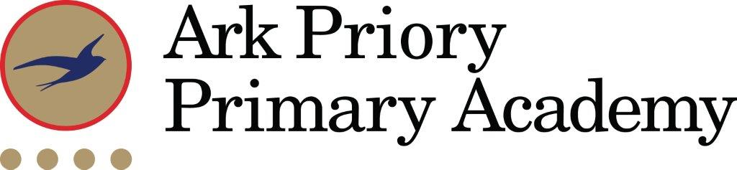
Teaching Assistant
Explore, Endeavour and Excel in an outstanding Ark School in West London
Teaching Assistant Vacancy

Reporting to: Assistant Head
Location: Ark Priory Primary Academy
Contract: Fixed Term (to the end of the academic year with a view to extend)
Working Pattern: Term Time
Salary: £29,043 to £30,798 FTE £24,982 to £26.492 Actual
Disclosure level: Enhanced
Closing Date: Monday 2nd February 2026
Interviews to be held: W/C 9th February 2026

Ark Priory admitted its first two reception and nursery classes (90 pupils) in September 2013 and in 2019/2020, we had our first cohort of Year 6 pupils. It is a mixed, non-denominational, two form entry primary school for local children in Acton. It offers an inclusive and inspiring education in a community school with the highest possible aspirations for its pupils. We place great emphasis on supporting our pupils to reach their full potential and beyond, to develop and grow to become well-rounded and conscientious citizens of the world that offer a positive contribution to society. Ark Priory had a highly successful first year and was graded outstanding by Ofsted (June 2025).
​
Our mission, to ensure that all children can attend university or pursue a career of their choice, is incredibly important and something that we keep at the forefront of our minds every day, through our academy values of ‘Explore, Endeavour and Excel’ – today we lay the foundations for tomorrow’s success. By the end of their time at Ark Priory, we expect all children to possess the characteristics highlighted in our ‘Ark Priory child’.
​
Pupils are proud to be Ark Priory pupils and reflect the positive and respectful school culture in which all staff know and care about our pupils. We celebrate togetherness and what makes us part of our unique Ark Priory community, as well as valuing and nurturing differences; in our school bullying, harassment and violence are never tolerated.
​
Joining Ark Priory Primary Academy is an exciting opportunity to work in an outstanding setting which offers lots of potential and opportunity to embark on a rewarding career path
Our ideal candidate will:

- be a positive role model for the pupils in their care,
- believe in the potential of every child and be committed to seeing that every child reaches that potential,
- be able to inspire learning beyond the classroom, ensuring that learning doesn’t stop once the school day ends,
- possess the skills and determination to make a significant difference to the lives of the children,
- be happy to contribute to the success of this exciting new learning community.

Our core values are “courage,” “exploration,” “endeavour” and “excellence.” We take great pride in the diversity of our student body, celebrating all backgrounds and cultures. Our community is already very strong and we are fortunate to have a committed and supportive parent body.
If you are an outstanding individual who has drive and enthusiasm, and who will relish a rewarding, new opportunity please submit an application today.
Ark is committed to safeguarding children; successful candidates will be subject to an enhanced Disclosure and Barring Service check.

Teaching Assistant Vacancy

Reporting to: Assistant Head
Location: Ark Priory Primary Academy
Contract: Fixed Term (to the end of the academic year with a view to extend)
Working Pattern: Term Time
Salary: £29,043 to £30,798 FTE £24,982 to £26.492 Actual
Disclosure level: Enhanced
Closing Date: Monday 2nd February 2026
Interviews to be held: W/C 9th February 2026

The Role
As a Teaching Assistant you will support pupils, parents, and teachers, to establish a supportive learning environment in which children make good academic progress. You will be instrumental in our mission to provide every student, regardless of their background, a great education and real choices in life.

Key Responsibilities
Learning Support
- Support pupil learning through the delivery of specific learning programmes, setting high expectations whilst encouraging their independence and building their confidence
- Promote inclusion, encouraging pupils to interact and work collaboratively
- Adapt and develop resources for EAL and SEND pupils, ensuring their safety and enabling them to access the curriculum
- Assist with follow-through for related services (speech/language/physical therapy etc.)
- Observe, record and feedback information of pupil performance
- Use strategies, in liaison with the teacher to assist in behaviour management and to support pupils in their learning objectives
- Assist pupils' achievement outside of the classroom, e.g. computer lab, library
Support for the school
- Supervise pupils in playgrounds, lunchrooms etc and assist with general pastoral care
- Accompany teachers and pupils on trips and out of school activities as required within contract hours, taking responsibility for pupils under the supervision of the teacher

Other
- Actively promote the safety and welfare of our children and young people
- Ensure compliance with Arks data protection rules and procedures
- Liaise with colleagues and external contacts at all levels of seniority with confidence, tact and diplomacy
- Work with Ark Central and other academies in the Ark network, to establish good practice throughout the network, offering support where required

This job description is not an exhaustive list and you will be expected to carry out any other reasonable tasks as directed by your line manager.

Person Specification: Teaching Assistant

Qualifications
- Maths and English GCSE or equivalent at grade C or above (or equiv)
- Certified teach assistant course or training or willingness to undertake this
- Degree (desirable)

Knowledge, Skills and Experience
- Experience establishing successful learning relationships with students at the relevant age, treating them consistently with respect and consideration
- Experience of the role of a TA including; classroom organisation and management, supporting the planning and delivery of the curriculum, implementing behaviour and learning strategies
- Good working knowledge of the national curriculum
- Good numeracy and literacy skills
- Good administrative, organisational and computer skills
- Competent with computers and other technology
- Excellent communication and interpersonal skills with children and adults
- Able to deal with minor incidents, first aid, and pupil’s personal health and hygiene
- Able to speak another language, play a musical instrument or coach a sport (desirable)

Behaviours
- Genuine passion for and a belief in the potential of every pupil
- A robust awareness of keeping children safe, noticing safeguarding and welfare concerns, and you understand how and when to take appropriate action.
- Belief that every student should have access to an excellent education regardless of background
- Professional outlook, detailed orientated and able to multi task and meet deadlines
- A team player that can work collaboratively as well as using own initiative
- Helpful, positive, patient and caring nature
- Calm and professional under pressure
- Understanding of the importance of confidentiality and discretion
- Flexible attitude towards work and demonstrates sound judgement

Other
- Right to work in the UK
- Commitment to equality of opportunity and the safeguarding and welfare of all students
- Willingness to undertake training
- This post is subject to an enhanced DBS check

Ark is committed to safeguarding and promoting the welfare of children and young people in our academies. In order to meet this responsibility, we follow a rigorous selection process. This process is outlined here, but can be provided in more detail if requested. All successful candidates will be subject to an enhanced Disclosure and Barring Service check.

