

Lead Teacher of Physical Education

Reporting to: Assistant Headteacher Co-curricular
Location: Ark Greenwich Free School
Contract: Permanent
Working Pattern: Full Time
Start date: September 2026
Salary: Ark MPS/UPS, Inner London. A TLR is available for this
position.

Applications close: Tuesday 14th April 2026 at 11:59pm
The school reserves the right to withdraw this advert if a suitable candidate is appointed before the closing date. Applicants are strongly encouraged to apply early for this role to avoid disappointment.

Ark Greenwich

Click here to view our school video.
This is a rare and exciting opportunity to work at one of the highest performing schools in the country. If you are committed to making a lasting difference in our local community and want to work in a seriously ambitious, respectful and high performing school, this could be the job for you.

At Ark Greenwich we take the wellbeing and workload of our staff seriously. We are committed to sustainable high performance and recognise our staff are our primary resource. To find out how we approach staff wellbeing, please click here

Ark Greenwich is a new, ambitious school model based on what we know excellent schools do. We have created a highly respectful and disciplined environment where our staff and scholars can fulfil their potential. We are one of the highest performing schools in the UK. 2025 Progress 8 estimate: +1.64, EM4+: 98%, EBacc entry rate: 73%.

Ark Greenwich exists to empower young people, regardless of socio-economic background, to grow and be successful. This is an ambitious and forward-thinking school that encourages innovation and values its staff. We are proud of our highly respectful and disciplined community and of the outstanding academic outcomes achieved by our scholars. Expectations for all members of our community are unashamedly sky high. We work tirelessly to impact the lives of the young people we serve. Scholars at our school are passionate about Humanities and achieve exceptional outcomes. We also place a primacy on our industry leading extra-curricular and character education programmes.

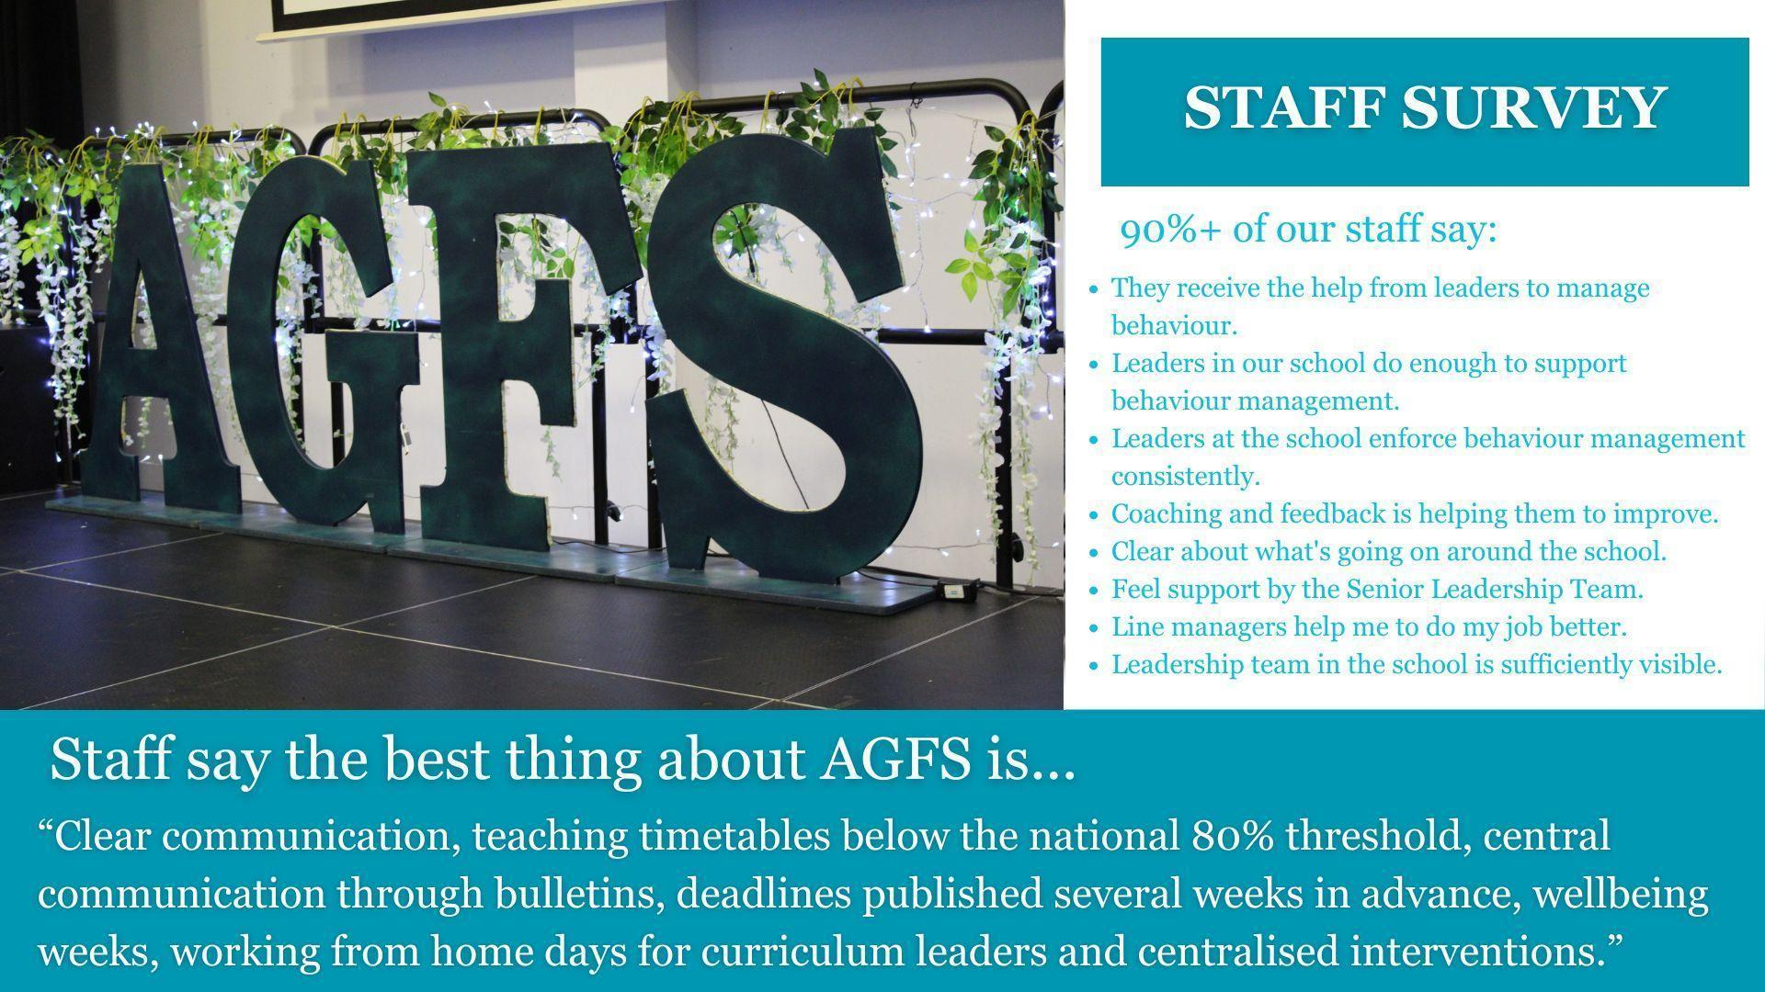

How is Ark Greenwich different?
- We are part of the Ark family of schools and benefit accordingly from outstanding networking and career opportunities and first-class CPD.
- Staff wellbeing is one of our main priorities. We provide breakfast for staff each morning, lunch for early careers staff and have a 6pm/weekend work-related communication cut off. We do not do knee jerk reactions, fads or last-minute deadlines. Our systems and processes for communication, marking and feedback and assessment are streamlined and the approaches we take are research led and based on our local context. We offer a WFH day to HoDs for curriculum design and also offer external marking of scripts to support workload. Our full approach to staff wellbeing/workload can be found here.
- This is a small school model (600 scholars aged 11-16) because we believe that our close-knit family community provides the optimum conditions for success.
- Scholar behaviour is exceptional with clearly defined and embedded routines. This means our teachers can focus their time on the things that matter – planning and delivering brilliant lessons for our scholars.
- This is a strict no excuses, no mobile phone school. Phones are not permitted onsite at all. Scholars wear business dress to prepare them for a professional career.
- Our curriculum is traditional and academic, and we do not take shortcuts to seek to boost our position in school league tables – we do not, for example, offer equivalencies such as Btecs or Vcerts..
- We put high-quality teaching at the heart of what we do. We are committed to providing staff with weekly high-quality training. We run coaching for staff who want to see rapid progress in their discipline. Live coaching and current best practice in the field of education is central to our approach.
- We don’t grade individual lessons or ask for lesson plans but we do place a primacy on curriculum design, independent learning and formative assessment.
- Our scholars enjoy a compulsory co-curricular program on a Wednesday afternoon which includes a strong focus on community volunteering and we facilitate 6 drop-down days per academic year ensuring scholars benefit from a range of life-enriching experiences.

Alignment with the school’s vision, values and approach to education is essential.

The Role and the Department
We are seeking an enthusiastic and committed Lead Teacher of Physical Education to join our team at AGFS. This is an excellent opportunity for a passionate educator to inspire scholars to develop a lifelong interest in physical activity, health, and wellbeing.

You will be part of a professional community and promote outstanding teaching and learning and a strong school culture within a nurturing, respectful and academically rigorous environment. The successful candidate will be capable of adding further value to a traditionally strong subject at the school. A passion for your subject and a commitment to extra-curricular activities including competitive sport is essential.

We invest heavily in our exciting PE department; dedicating 2 hours a week to PE for every scholar in KS3 and 1 hour at KS4 for core PE. While we do not offer GCSE PE, our curriculum places strong emphasis on enjoyment, fitness, and broad exposure to a range of sports and activities. Scholars are involved with several high-quality extracurricular clubs including basketball, netball, athletics, cross country and football. Staff from other departments actively contribute to the PE extra-curricular programme.

This post would suit an ambitious, research-informed, subject specialist who is driven to develop a department that becomes a beacon of PE provision in the UK.

About Ark Schools
Ark is a network of high-achieving, non-selective schools and one of the country’s top-performing academy groups. We run 39 academies in London, Birmingham, Hastings and Portsmouth educating more than 26,000 scholars. 83% of Ark schools are now rated as good or outstanding by Ofsted.
Our aim is to create outstanding schools that give every scholar, regardless of their background, the opportunity to go to university or pursue the career of their choice.
To find out more about Ark Greenwich, please visit our website via www.arkgreenwichfreeschool.org
Ark value diversity and are committed to safeguarding and promoting child welfare. The successful candidate will be subject to DBS and any other relevant employment checks.

Job Description: Secondary Lead Teacher of PE

Reporting to: Assistant Headteacher Co-curricular
Location: Ark Greenwich Free School
Contract: Permanent
Working Pattern: Full Time
Start date: September 2026
Salary: Ark MPS/UPS, Inner London. A TLR is available for this
position.

Applications close: Tuesday 14th April 2026 at 11:59pm

The Role
You will be instrumental in our mission to provide every scholar a great education and real choices in life, regardless of their background. A passionate practitioner, you will deliver high-quality, rigorous lessons that drive achievement and inspire a love of learning that extends beyond the classroom.
Key Responsibilities
- Set high expectations so that all scholars are inspired, motivated and challenged to reach their full potential, and in doing so meet their progress and attainment targets
- Plan and teach well-structured, differentiated lessons that are aligned to the agreed curriculum and cultivate every scholar’s intellectual curiosity
- Provide frequent and incisive scholar feedback in line with school policy
- Use data to inform teaching and learning, identify areas for intervention and provide feedback to scholars, staff and families in order to promote progress and outcomes
- Manage behaviour effectively to create a safe, respectful and nurturing environment so that scholars can focus on learning
- Work collaboratively with both school and network colleagues as a committed team member, building successful, high performing teams
- Participate actively throughout the school and network, by attending relevant meetings and CPD
- Attend school events, including but not exclusive to parents’ evening and Prize Evening
- Work with colleagues, scholars and families to develop a strong school community
- Follow all school rules and procedures

Other
- Actively promote the safety and welfare of our children and young people
- Ensure compliance with Ark data protection rules and procedures
- Liaise with colleagues and external contacts at all levels of seniority with confidence, tact and diplomacy
- Work with Ark Central and other academies in the Ark network, to establish good practice throughout the network, offering support where required

Professional Development
As a teacher:
- Take responsibility for your own professional development and demonstrate a commitment to continuous professional development by undertaking, and seeking out, opportunities to build your capabilities as a teacher.
- Maintain an up-to-date expert knowledge of your subject area, related teaching pedagogy and relevant aspects of the National Curriculum, exam board requirements and other statutory provisions, including developments and reforms in broader education policy.
- Ensure you understand your professional responsibilities in relation to school policies and practices.
- Evaluate your own teaching critically and use this to improve your effectiveness.
- Engage, positively, with the AGFS performance-management system.
- Support colleagues when working in your teacher learning communities.

Non-Subject Responsibilities
- Demonstrate consistently high expectations of all scholars and a commitment to raising their achievement and social and emotional well-being. Promote the positive values, attitudes and behaviour expected from all scholars by treating them with respect and consideration.
- Develop strong and positive relationships with scholars.
- Implement all school policies, including the school’s behaviour policy.
- Contribute to the design and delivery of the school’s enrichment curriculum in line with your timetable and the AGFS enrichment policy.
- Model the ethos and vision of the school at all times.
- Communicate promptly and sensitively with parents, carers and other relevant bodies where necessary.
- Contribute to the school’s liaison, marketing and scholar recruitment activities, e.g. the collection of material for press releases.
- Establish and maintain effective working relationships with colleagues including support staff.
- Be familiar with and comply with the School’s Health and Safety policies
- Be responsible for the health & safety of scholars when they are authorised to be on school premises and when engaged in authorised activities elsewhere
- Adhere, at all times, to the expectations of teachers at Ark Greenwich Free School, outlined on the final page of this document.
- Any other duties as required by the Headteacher commensurate with the post.

Notes
All new staff will be subject to a probation period of six months (which may, in certain circumstances, be extended by up to 10 weeks). The probation period is a trial period, to enable the assessment of an employee’s suitability for the job for which he or she has been employed. It provides the school with the opportunity to monitor and review the performance of new staff in relation to various areas, and also in terms of their commitment to safeguarding and relationships with scholars.
No job description can be fully comprehensive, and from time to time the successful candidate may have to undertake other professional duties as directed by the Headteacher/Senior Leadership Team.

Person Specification: Secondary Lead Teacher

Qualification Criteria
- Qualified to teach and work in the UK
- Degree in a Physical Education or related subject
Knowledge, Skills and Experience
- Demonstrable commitment to raising attainment of all scholars in a challenging classroom environment
- Excellent understanding of both subject and general teaching pedagogy
- Experience of teaching PE at KS3 and KS4
- Be or demonstrate the potential to become an outstanding lead teacher
- Effective and systematic behaviour management
- Knowledge of the national secondary education system, examinations and curriculum
Behaviours
- Genuine passion for and a belief in the potential of every scholar
- A robust awareness of keeping children safe, noticing safeguarding and welfare concerns, and you understand how and when to take appropriate action
- Deep commitment to Ark’s mission of providing an excellent education to every scholar, regardless of background
- Excellent interpersonal, planning and organisational skills
- Resilient, motivated and committed to achieving excellence
- Reflective and proactive in seeking feedback to constantly improve practice
- Commitment to regular and on-going professional development and training to establish outstanding classroom practice.
- Commitment to and understanding of professionalism in line with the National Teaching Standards
Other
- Right to work in the UK
- Commitment to equality of opportunity and the safeguarding and welfare of all scholars
- Willingness to undertake training
- This post is subject to an enhanced DBS check
Ark is committed to safeguarding and promoting the welfare of children and young people in our academies. All successful candidates will be subject to an enhanced Disclosure and Barring Service check.

