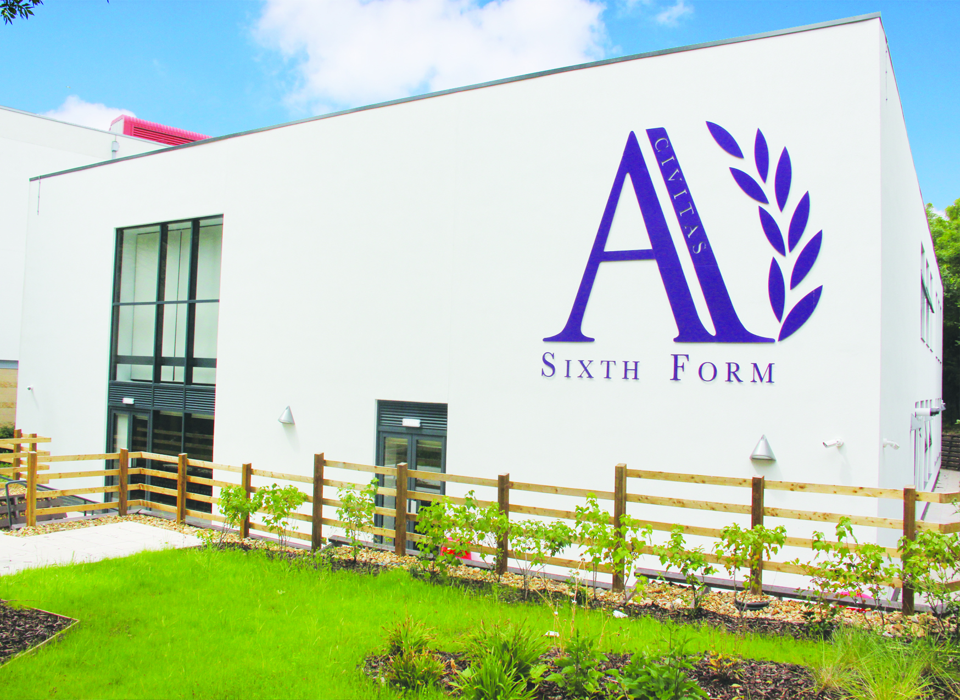

Opportunity to join an ‘Outstanding’ all-through academy specialising in mathematics and citizenship.
Physics
Teacher

Candidate
Information
Pack

Dear Candidate,
Thank you for taking the time to find out more about Ark Academy. This pack is intended to give you information about the role of physics Teacher, together with details of the Academy’s vision, ethos and aspirations.
We are looking to recruit a talented and inspiring teacher who is committed to helping our students fulfil their potential.
We are very proud of our reputation for academic excellence and the superb pastoral care our students receive along with the support we provide for the less academically able. We now want your help to enable us to go beyond outstanding and achieve ‘excellence for all’.
The science department is well resourced and fully staffed. We have 10 Science Laboratories and have a strong take up of science in the sixth form for ‘A’ levels + BTEC Level 3 applied science.
The Academy has an excellent record of support for professional development and there is a comprehensive programme of support for NQTs.
To apply, follow the link at https://arkacademy.org/vacancies by 8:00am on Friday 13th March 2026. A golden hello is available to the successful applicant, if the application is made directly through the school’s website.
For an informal, conversation about the role, please contact Eddie Honein, Director of Science on 020 8385 4370 or via email, e.honein@arkacademy.org
We wish you the best with your application.
Delia Smith OBE

Principal

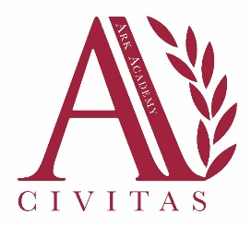
Ark Academy

The Principal
Delia Smith is the founding principal of Ark Academy. Previously she was the headteacher of St Angela’s Ursuline School in Forest Gate for 16 years. She has also been a schools’ inspector and was awarded an OBE for services to education.

About Ark Academy
We are a non-selective school specialising in mathematics and citizenship that serves children of all abilities. Our commitment is to know every pupil as an individual, and to foster the principles of team spirit, responsibility and care for others. Our pupils enjoy both a nurturing environment and the social benefits of a small school and the range and resources of a large, well equipped academy.
Facilities
Our buildings were designed by award winning architects Studio E (who created the successful design for City of London Academy in Southwark) and are organised to support calm and ordered learning. Pupils have access to specialist indoor and outdoor sports facilities, excellent science and ICT facilities, music, Design and Technology, art and drama studios and a 150 sqm, well-stocked and up-to-date library as well as inviting and well-equipped classrooms

About ARK Schools
ARK Schools is an education charity set up in 2004 to create a network of high achieving, non-selective, inner city schools where all pupils, regardless of their background or prior attainment, achieve highly enough by age 18 to have real choices: to go on to university or the career of their choice. ARK Schools has no faith affiliations.

All the ARK schools are situated in areas of high deprivation or educational need and our pupil profile reflects this: over half of our pupils are eligible for free school meals compared to 18% nationally.

The ARK network operates 38+ schools in the UK across London, Portsmouth, Birmingham and Hastings Each of our schools has its own distinctive character, reflecting its local community.

About the Science Department
The Science department is a team of 15 passionate and collegiate scientists and is supported by 2 Technicians, across 10 modern and well-appointed labs.

We teach Science within the strands of Physics, Chemistry and Biology to all students from Yr7 to 11 and offer Physics, Chemistry, Biology and Professional Pathways Applied Science at sixth form.

As a department we aim to:
- Develop and inspire a generation of Scientific learners and deliver the promise of our school mission statement; in particular “high aspirations, high motivation and high achievement for all.”
- Inspire independent, lateral thinking, risk takers who will go onto be leaders and major players in a greener, safer scientific world.
- Develop an enquiring and questioning frame of mind to understand how science works.
- Expand the ability to solve problems in unfamiliar situations.
- Make science relevant to everyday life and link it to pupils own experience.
- Utilise a disciplined scientific investigative method to solve problems in a disciplined way
- Appreciate the contribution science makes to society and realise that applying science can lead to moral and ethical issues having to be addressed
- Appreciate the powerful, but provisional nature of scientific knowledge and explanation and understanding that science is always developing
Give students access to careers in science and technology at a variety of levels
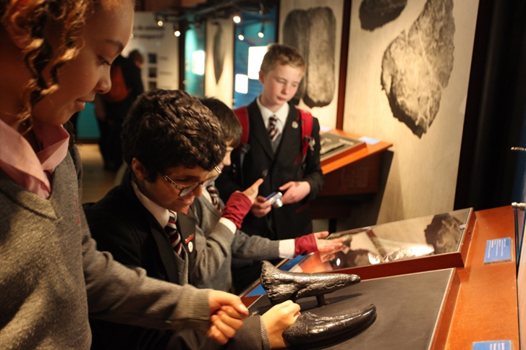
Job Description: physics Teacher
Reporting to: Director of science
Start Date: September 26
Contract: Full Time Permanent
Salary: Ark Main/Upper Pay scales paid at Inner London Rates.
The Role
To deliver outstanding teaching and learning of their subject and therefore help students achieve excellent results, and be a role-model/impact the academy more widely.
To design an engaging and challenging curriculum that inspires children to appreciate the subject and its application.
Key Responsibilities
- To plan, resource and deliver lessons and sequences of lessons to the highest standard that ensure real learning takes place and students make superior progress
- To provide a nurturing environment that helps students to develop as learners
- To help to maintain/establish discipline across the whole academy
- To contribute to the effective working of the academy.
Outcomes and Activities
Teaching and Learning
- With direction from the Director of Science and in the context of collaborative co-planning, plan and prepare effective lessons that are appropriately differentiated.
- Teach engaging lessons that motivate, inspire and improve pupil attainment
- Use assessments data analytically to monitor student progress and to plan/adapt future lessons to the needs of the students.
- Contribute to assessments, reports and references relating to individual and groups of pupils
- Ensure that all students achieve at least at chronological age level or, if well below level, make significant and continuing progress towards achieving at chronological age level
- Prepare pupils for external examinations and support departmental revision / intervention strategies
- Contribute to the department’s enrichment programme
- Implement and adhere to the academy’s Behaviour and Ethos Policy, ensuring the safety and well-being of pupils is monitored at all times.
- Maintain regular and productive communication with pupils, parents and carers, to report on progress, sanctions and rewards and all other communications
- Direct and supervise learning support staff assigned to lessons and any other adults that might be in lessons.
Academy Culture
- Support the academy’s values and ethos by contributing to the development and implementation of policies practices and procedures
- Help create a strong academy community, characterised by consistent, orderly behaviour and caring, respectful relationships
- Help develop the department culture and ethos that is utterly committed to achievement
- To be active in issues of student welfare and support
- Support and work in collaboration with colleagues and other professional in and beyond the school, covering lessons and providing other support as required.
Other
- Undertake, and when required, deliver or be part of the appraisal system and relevant training and professional development
- Undertake other various responsibilities as directed by the Head of Department or Principal.

Person Specification: Physics Teacher
Qualification Criteria
- Qualified to degree level and above
- Qualified to teach and work in the UK.
Experience
- Experience of raising attainment in a challenging environment
- Experience of reflecting on and improving teaching practice to increase student achievement
- Evidence of continually improving the teaching and learning of their subject though schemes of work and extra-curricular activities.
Knowledge
- Up to date knowledge in the curriculum area
- Understanding of the strategies needed to establish consistently high aspirations and standards of results and behaviour.
Behaviours Leadership
- Effective team worker and leader
- High expectations for accountability and consistency
- Vision aligned with Ark’s high aspirations, high expectations of self and others
- Genuine passion and a belief in the potential of every student
- Motivation to continually improve standards and achieve excellence
- Effective listening skills that lead to a strong understanding of others
- Commitment to the safeguarding and welfare of all pupils.
Teaching and Learning
- Excellent teacher with the ability to reflect on lessons and continually improve their own practice
- Effective and systematic behaviour management, with clear boundaries, sanctions, praise and rewards
- Thinks strategically about classroom practice and tailoring lessons to students’ needs
- Understands and interprets complex student data to drive lesson planning and student attainment
- Good communication, planning and organisational skills
- Demonstrates resilience, motivation and commitment to driving up standards of achievement
- Acts as a role model to staff and students
- Commitment to regular and on-going professional development and training to establish outstanding classroom practice.
Other
- Commitment to equality of opportunity and the safeguarding and welfare of all pupils
- Willingness to undertake training

This post is covered by Part 7 of the Immigration Act (2016) and therefore the ability to speak fluent English is an essential requirement for the role.
Ark is committed to safeguarding and promoting the welfare of children and young people in our academies. In order to meet this responsibility, we follow a rigorous selection process. This process is outlined here, but, can be provided in more detail if requested. All successful candidates will be subject to an enhanced Disclosure and Barring Service check.
ARK Safe Recruitment Procedure

ARK is committed to safeguarding and promoting the welfare of children and young people in its academies. In order to meet this responsibility, its academies follow a rigorous selection process to discourage and screen out unsuitable applicants.

Disclosures
This post is classified as having substantial access to children, and appointment is subject to an enhanced police check of previous criminal convictions (DBS). Applicants are required, before appointment, to disclose any conviction, caution or binding over including ‘spent convictions’ under the Rehabilitation of Offenders Act 1974 (Exemptions) Order 1975. Non-disclosure may lead to termination of employment. However, disclosure of a criminal background will not necessarily debar individuals from employment – this will depend upon the nature of the offence(s) and when they occurred.

Reference Checking
References from the previous and current employer will be taken up for shortlisted candidates, and where necessary employers may be contacted to gather further information

Probation
All new staff will be subject to a probation period of six months (which may, in certain circumstances, be extended by up to 10 weeks). The probation period is a trial period, to enable the assessment of an employee’s suitability for the job for which they have been employed. It provides the academy with the opportunity to monitor and review the performance of new staff in relation to various areas, but also in terms of their commitment to safeguarding and relationships with pupils.

WHERE TO FIND US

Wembley Park (Jubilee/Metropolitan Line)


Chiltern Railways


Buses: 206, 245,297,83, 182

By Car: A479
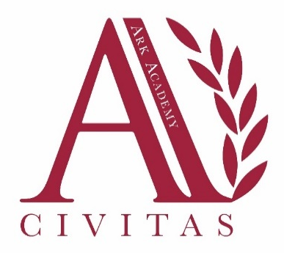
Postcode for satnav: HA9 9JP
A406 North Circular Road (15 minutes away)

Ark Academy Bridge Road London HA9 9JP
Tel: +44 (0)20 8385 4370
Email: admin@arkacademy.org
Website: www.arkacademy.org

